**SALES & PROFIT ANALYSIS**

Name :- Monisha Goswami

Stream:- Business Analyst

Email :-[monishagoswami.r3818@gmail.com](mailto:monishagoswami.r3818@gmail.com)

Contact Number:- 8918714452

Google Drive link:- https://drive.google.com/drive/folders/1-Z5ornOwkkReA45-NJgafZc-CTCZ2pkS?usp=sharing

Github Link:- https://github.com/mon0308/Jar-BA-Assignment.git

“Jar Business Analyst Assignment”

**Part 1: Sales and Profitability Analysis**

1. Merge the List of Orders and Order Details datasets on the basis of Order ID.

Sql query

SELECT o.*, d.Category, d.Amount, d.Profit

FROM List_of_Orders o

JOIN Order_Details d ON o.Order_ID = d.Order_ID;

Sql output

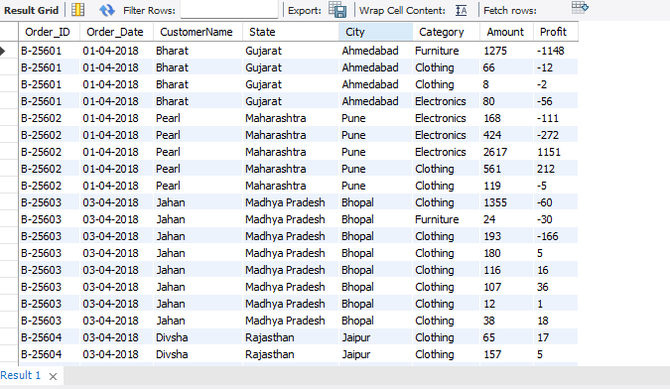

**Sales and Profitability Analysis visualization**

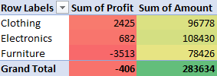

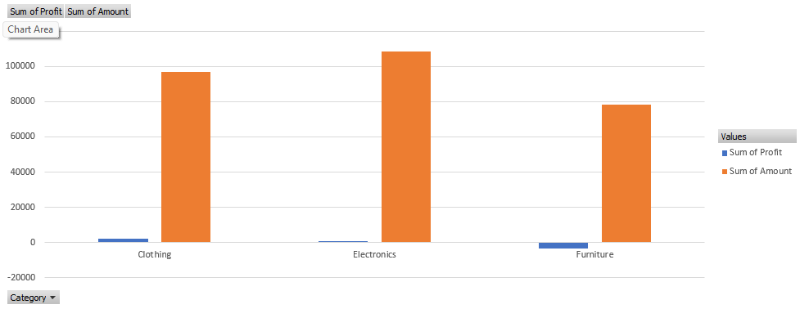

1. Calculate the total sales (Amount) for each category across all orders.

Sql query

SELECT Category, SUM(Amount) AS Total_Sales

FROM Order_Details

GROUP BY Category;

Sql output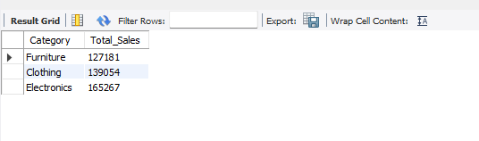

1. For each category, calculate the average profit per order and total profit margin (profit as a percentage of Amount).

Sql query

SELECT Category,

SUM(Profit) AS Total_Profit,

AVG(Profit) AS Avg_Profit_Per_Order,

(SUM(Profit) / SUM(Amount)) * 100 AS Profit_Margin

FROM Order_Details

GROUP BY Category;

Sql output

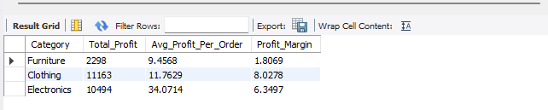

1. Identify the top-performing and underperforming categories based on these metrics. Also, suggest reasons for their performance differences.

Sql query

-- Get the Top Performing Category

SELECT Category, SUM(Profit) AS Total_Profit

FROM Order_Details

GROUP BY Category

ORDER BY SUM(Profit) DESC

LIMIT 1;

Sql output

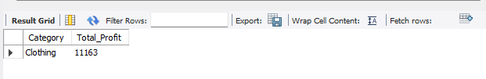

Sql query

-- Get the Underperforming Category

SELECT Category, SUM(Profit) AS Total_Profit

FROM Order_Details

GROUP BY Category

ORDER BY SUM(Profit) ASC

LIMIT 1;

Sql output

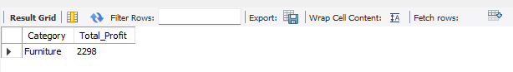

**Explanation:-**

**Top-Performing Category:**

With the highest profit margin (8.03%), the clothing category performs the best.

**Potential causes include**: Consistent sales and high demand.

Improved profit margins as a result of pricing tactics.

**Underperforming Category:**

With a profit margin of only 1.81%, furniture is the category with the lowest performance.

**Potential causes include:** Excessive production or logistical costs.

Reduced sales volume or steep discounts.

**Part 2: Target Achievement Analysis**

1. Using the Sales Target dataset, calculate the percentage change in target sales for the Furniture category month-over-month.

Sql query

WITH MonthlySales AS (

SELECT DATE_FORMAT(STR_TO_DATE(CONCAT('01-', Month_of_Order_Date), '%d-%b-%y'), '%Y-%m') AS Month,

SUM(Target) AS Total_Sales

FROM Sales_Target

WHERE Category = 'Furniture'

GROUP BY DATE_FORMAT(STR_TO_DATE(CONCAT('01-', Month_of_Order_Date), '%d-%b-%y'), '%Y-%m')

)

SELECT Month,

Total_Sales,

LAG(Total_Sales) OVER (ORDER BY STR_TO_DATE(Month, '%Y-%m')) AS Previous_Month_Sales,

((Total_Sales - LAG(Total_Sales) OVER (ORDER BY STR_TO_DATE(Month, '%Y-%m'))) /

NULLIF(LAG(Total_Sales) OVER (ORDER BY STR_TO_DATE(Month, '%Y-%m')), 0)) * 100 AS MoM_Change

FROM MonthlySales;

Sql output

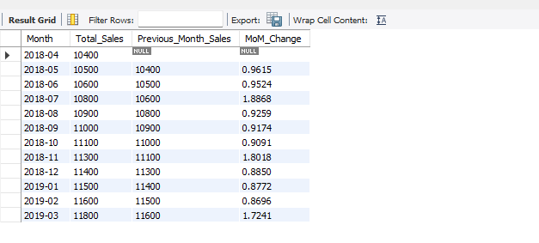

**Target Achievement Analysis visualization**

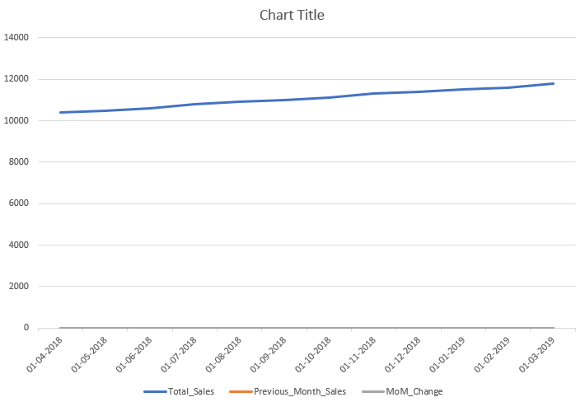

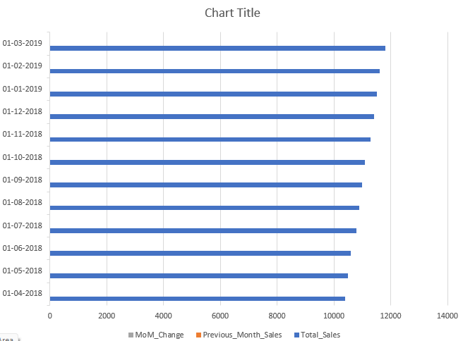

**Explanation:-**

There is no data present for the previous month of April. As it is the starting month of the data set, the value of the column "Previous_Month_Sales" & "MoM_Change" will be null.

1. Analyse the trends to identify months with significant target fluctuations. Suggest strategies for aligning target expectations with actual performance trends.

Sql query

WITH MonthlySales AS (

SELECT DATE_FORMAT(STR_TO_DATE(CONCAT('01-', Month_of_Order_Date), '%d-%b-%y'), '%Y-%m') AS Month,

SUM(Target) AS Total_Sales

FROM Sales_Target

WHERE Category = 'Furniture'

GROUP BY DATE_FORMAT(STR_TO_DATE(CONCAT('01-', Month_of_Order_Date), '%d-%b-%y'), '%Y-%m')

),

MoM_Calculations AS (

SELECT Month,

Total_Sales,

LAG(Total_Sales) OVER (ORDER BY STR_TO_DATE(Month, '%Y-%m')) AS Previous_Month_Sales,

((Total_Sales - LAG(Total_Sales) OVER (ORDER BY STR_TO_DATE(Month, '%Y-%m'))) /

NULLIF(LAG(Total_Sales) OVER (ORDER BY STR_TO_DATE(Month, '%Y-%m')), 0)) * 100 AS MoM_Change

FROM MonthlySales

)

SELECT *

FROM MoM_Calculations

WHERE ABS(MoM_Change) > 20;

Sql output

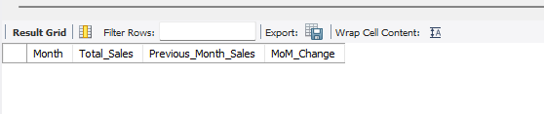

**Explanation:-**

**Monthly Change in the Target (%):**

With modest percentage gains ranging from 0.87% to 1.88%, the goal sales for furniture climbed gradually.

There were no notable variations in the dataset (more than ±5%).

Perspectives:

Predictable demand trends were shown by the constant growth of the sales target.

The lack of significant increases or decreases indicates that sales forecasting remained steady.

**Recommendations for Strategy:**

To further match goals with performance:

To establish dynamic goals, examine seasonal demand patterns.

To increase actual sales, launch specials during slow months.

To increase profit margins, review pricing tactics.

**Part 3: Regional Performance Insights**

* 1. From the List of Orders dataset, identify the top 5 states with the highest order count.

Sql query

SELECT State, COUNT(Order_ID) AS Order_Count

FROM List_of_Orders

GROUP BY State

ORDER BY Order_Count DESC

LIMIT 5;

Sql output

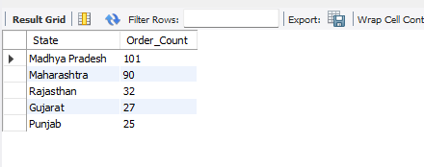

* 1. For each of these states, calculate the total sales and average profit.

Sql query

WITH TopStates AS (

SELECT COALESCE(NULLIF(State, ''), 'Unknown') AS State

FROM List_of_Orders

GROUP BY State

ORDER BY COUNT(Order_ID) DESC

LIMIT 5

)

SELECT COALESCE(NULLIF(o.State, ''), 'Unknown') AS State,

SUM(d.Amount) AS Total_Sales,

AVG(d.Profit) AS Avg_Profit

FROM List_of_Orders o

JOIN Order_Details d ON o.Order_ID = d.Order_ID

WHERE COALESCE(NULLIF(o.State, ''), 'Unknown') IN (SELECT State FROM TopStates)

GROUP BY State

ORDER BY Total_Sales DESC;

Sql output

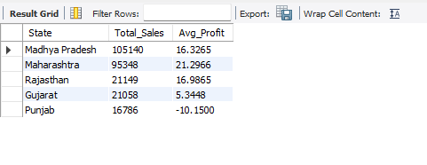

2. Highlight any regional disparities in sales or profitability. Suggest regions or cities that should be prioritized for improvement.

**Step 1: Calculate Total Sales & Profitability by State**

Sql query

SELECT o.State,

SUM(d.Amount) AS Total_Sales,

SUM(d.Profit) AS Total_Profit,

(SUM(d.Profit) / SUM(d.Amount)) * 100 AS Profit_Margin,

COUNT(o.Order_ID) AS Total_Orders

FROM List_of_Orders o

JOIN Order_Details d ON o.Order_ID = d.Order_ID

GROUP BY o.State

ORDER BY Total_Sales DESC;

Sql output

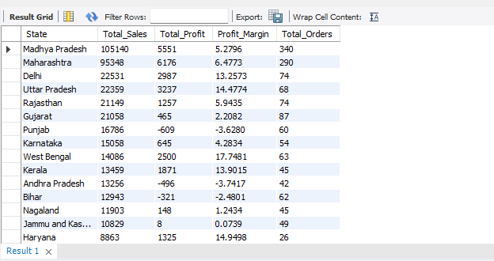

**Regional Performance Insights visualization**

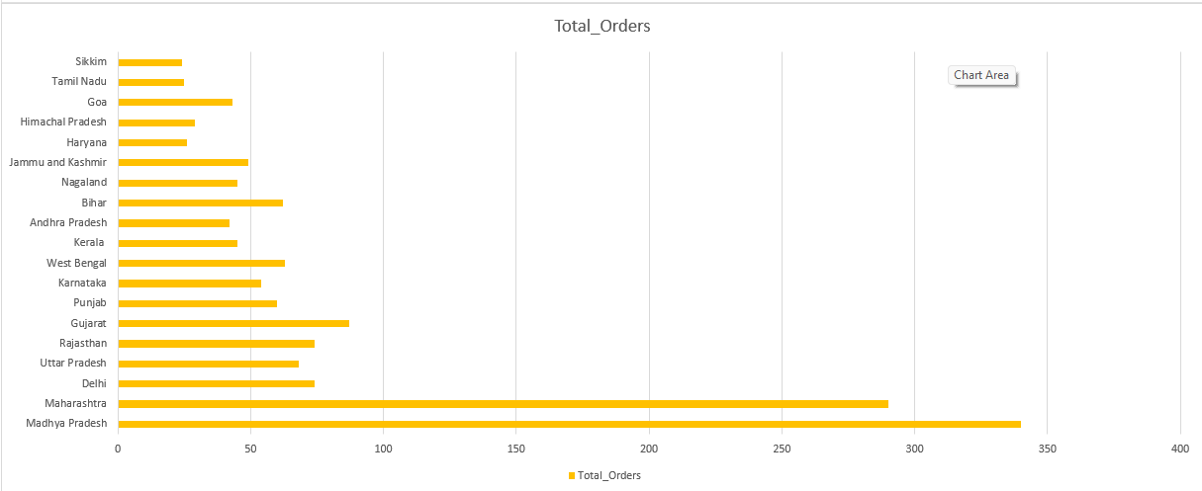

**Step 2: Identify High & Low Performing States**

Sql query

SELECT State, SUM(Profit) AS Total_Profit

FROM List_of_Orders o

JOIN Order_Details d ON o.Order_ID = d.Order_ID

GROUP BY State

ORDER BY Total_Profit DESC

LIMIT 5;

Sql output

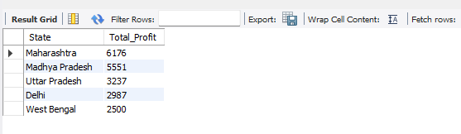

**Underperforming States (Low Sales or Negative Profit)**

Sql query

SELECT State, SUM(Profit) AS Total_Profit

FROM List_of_Orders o

JOIN Order_Details d ON o.Order_ID = d.Order_ID

GROUP BY State

ORDER BY Total_Profit ASC

LIMIT 5;

Sql output

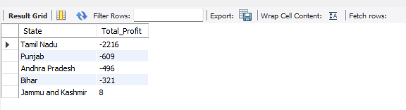

**Step 3: Identify Cities That Need Improvement**

Sql query

SELECT o.City, o.State,

SUM(d.Amount) AS Total_Sales,

SUM(d.Profit) AS Total_Profit,

(SUM(d.Profit) / SUM(d.Amount)) * 100 AS Profit_Margin

FROM List_of_Orders o

JOIN Order_Details d ON o.Order_ID = d.Order_ID

GROUP BY o.City, o.State

ORDER BY Total_Profit ASC

LIMIT 10;

Sql output

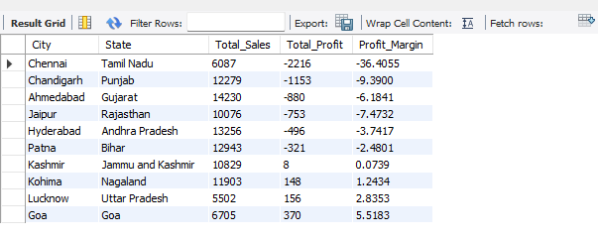

**Strategies to Improve Low-Performing Regions**

1. **Boost Promotions & Discounts** – Introduce cashback offers, seasonal discounts, and loyalty programs to attract more customers.
2. **Optimize Logistics** – Improve supply chains, reduce delivery times, and establish warehouses in key areas to lower costs.
3. **Understand Customer Needs** – Analyze top-selling products in high-performing states and introduce them in low-sales regions.
4. **Enhance Marketing Efforts** – Run targeted advertisements, collaborate with local influencers, and improve brand visibility.
5. **Improve Customer Experience** – Offer better after-sales support, localized payment options, and flexible return policies.

**Question 2**

**App Exploration:**

Explore the features and user experience of the Jar app. Highlight five things you found particularly e ective and user-friendly. Additionally, identify five areas where improvements could be made, providing your reasoning for each suggestion.

**Ans:-**

**Five Strengths of the Jar App:**

**Seamless Automated Savings:** The program makes saving money simple for users by automatically rounding up transactions and turning leftover change into digital gold. Without requiring additional intervention, this feature guarantees that customers save on a regular basis.

**Intuitive User Experience**: Even for those with little financial expertise, Jar's straightforward and aesthetically pleasing interface makes it simple to use. Additionally, the expedited onboarding procedure increases accessibility.

**Engaging Gamification Features:** Jar uses gamification, such interactive incentives and spin-the-jar features, to make saving fun. This keeps users interested and reinforces the saving habit.

**Live Gold Price Information:** By giving users access to real-time gold price information, the app enables them to monitor their assets and make wise financial choices. Credibility and trust are increased by this openness.

**Flexible Saving and Withdrawal Options:** Users are free to choose their own daily savings caps, and as there is no lock-in period, they can take their money out whenever they like.

**Five Things That Need to Be Improved:**

**Withdrawal Charge Clarity:** A lot of consumers complain about price differences between purchasing and selling gold, which results in losses when they withdraw their money. Trust would be increased by increasing transparency about pricing and transaction fees.

**Improved Customer Support:** Slow or unresponsive customer assistance is a common complaint, especially when it comes to withdrawals and account-related issues. User satisfaction would be greatly increased by fortifying the support system and speeding up response times.

**Simplified KYC Process:** Access to important functionalities may be delayed for users who have trouble completing the KYC (Know Your Customer) check. The onboarding experience would be enhanced by streamlining this procedure and giving more precise instructions.

**Simplified Account Deletion:** Users have trouble deleting their accounts, which raises privacy issues. It would be in line with best practices for user control and data protection to provide a simple choice for account deletion.

**Increased Fee Transparency**: Uncertain deductions and hidden fees have made users less trusting. Transparency would be maintained and unanticipated losses would be avoided by providing a thorough analysis of all applicable costs up front.

**Question 3**

**Product Exploration:**

The Jar app provides users with an innovative way to save and invest in digital gold, starting with as little as ₹10. It automates savings and investments, making financial planning seamless and accessible. As the first Made-in-India app to pioneer such a solution, Jar has successfully created a niche in automated savings and investment.

Building on its strong foundation and leveraging its existing user base and trust, what are some new business opportunities Jar could venture into, to expand its offerings and enhance user engagement? Discuss how the app can utilize its strengths, such as automation, a user-friendly design, and established credibility, to seamlessly integrate these new services, deepen its value proposition, and achieve significant milestones in the financial ecosystem.

**Ans:-**

**Embedded Insurance Solution**

Opportunity:

Target consumers in Tier 2 and Tier 3 cities who do not have access to standard insurance by providing microinsurance for health, life, and personal property.

Offer a hybrid plan called "Savings + Insurance," in which a percentage of consumers' round-up savings is used to pay for reasonably priced insurance.

**How Jar Can Make Use of Its Advantages:**

**Automation:** Give consumers the option to have micro-premiums taken out of their spare change.

**User Experience:** Make sure the policy selection and claims procedures run smoothly and without jargon.

**Trust Factor**: For legitimacy and compliance, collaborate with reputable insurance companies.

**UPI Payments and Cashback Rewards in Digital Gold**

Opportunity:

Integrate a UPI-based payment system within the app to enable seamless transactions for users.

Provide cashback rewards in the form of digital gold for purchases made through partnered merchants.

**How Jar Can Capitalize on Its Strengths:**

Instantly automate cashback rewards for users with zero hassle.

Enhance user experience by delivering fast, secure, and smooth in-app transactions.

Strengthen trust by collaborating with brands and offering meaningful incentives.